40.16: Since 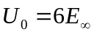 we can use the result 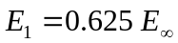from Section 40.3, so 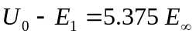and the maximum wavelength of the photon would be
